EENG 385 - Electronic Devices and Circuits

Frequency Domain: FFT and Fourier Series

Lab Handout

Objective

The objective of this lab is to study the frequency response of the modified Audio amplifier front end using the FFT feature of the oscilloscopes.

# Fast Fourier Transform/ Fourier Series:

Most modern oscilloscopes have a fast Fourier transform (FFT) capability. A FFT is a graph of power vs. frequency for one of input channels of the oscilloscope. In other words, the oscilloscope decomposes the input waveform into that waveform’s constituent sine waves (using the fast Fourier transform) and then plots the magnitude of each of these sine wave at their respective frequency.

Figure 1 shows the FFT of a 1kHz square wave applied to channel 1 of the oscilloscope. The horizontal axis is scaled at 2kHz per division. The vertical axis is the voltage of the sin wave component at that frequency. The vertical axis is scaled at 1V RMS per division with 0V indicated by the grey “FFT” arrow on the left margin of the screen.

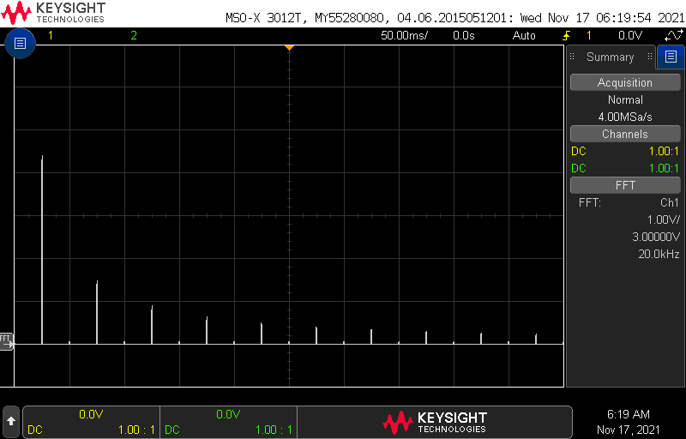

Figure : The FFT of a 1kHz square wave showing the Fourier series harmonics. The horizontal scale is 2kHz/division.

A close examination of the FFT in Figure 1 reveals a spike half way to the first vertical division, at 1kHz, that extends about 4.4 vertical division. This spike represents the energy of the 1kHz sine wave component of the square wave. The other sinusoidal components of the square wave show up as spikes at 3kHz, 5kHz, etc. In order to look at the FFT of a square wave let’s use a new piece of equipment in the lab, the BNC/BNC cable. This is just a cable with a BNC connector on each end shown in Figure 2.

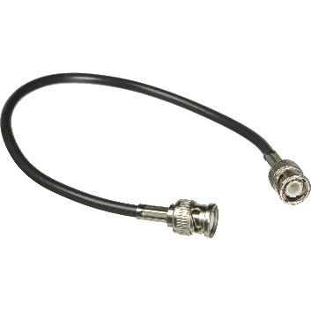

Figure : A BNC to BNC cable.

Configure you oscilloscope and function generator to look at the FFT of a square wave using the following procedure:

* Turn on the function generator and oscilloscope,
* Attach one end of the BNC/BNC cable to oscilloscope Ch1 and the other end to CH1 of the function generator,

Configure your function generator as follows:

* Waveform: Square
* Frequency: 1.0kHz
* Amplitude: 10.0V
* Offset: 0V

Configure Ch1 of the oscilloscope as follows:

|  |  |
| --- | --- |
| Horizontal (scale) | 1ms |
| Ch1 | BNC/BNC to CH1 of function generator |
| Ch1 (scale) | 5V/div |
| Ch1 (coupling) | DC |
| Trigger source | 1 |
| Trigger slope | ↑ |
| Trigger level | 0V |

You should see the square wave on the screen as expected. If present, remove Ch2 from the oscilloscope display by pressing the illuminated "2" button twice.

Add the FFT to the scope using the following instructions:

* [FFT] → Source: → 1
* [FFT] → Span → 20kHz
* [FFT] → Center: 10kHz
* [FFT] → More FFT
* [FFT] → Vertical Units→ V RMS
* [↑ Back] [↑ Back]
* Change the Horizontal scale from 1ms to 50ms. Note how FFT peak narrow.
* Remove the Channel 1 trace by pressing the illuminated “1” twice. Note, the waveform does not need to be present for the FFT function to work,
* Use the knobs to the right of the FFT button to
  + FFT scale 1V/
  + FFT offset 3V

You should see an image identical to Figure 1. Since we have configured the FFT for a span of 20kHz, each of the 10 horizontal divisions on the oscilloscope is 2kHz wide. The Fourier series allows you to represent a 0V–centered square wave with frequency ω0 and a 50% duty cycle as the sum of sinusoids using the Equation 1. Each of the cosine terms is called a harmonic with the n=1 term, $cos⁡(ω_{0})$ term being called the fundamental.

Equation : The Fourier series for a 50% duty cycle square wave centered at 0V.

$$\sum_{n odd}{\frac{1}{n}cos⁡(nω_{0})}$$

Note that Equation 1 does not contain any even harmonics. In other words, the coefficients of the $cos⁡(nω_{0})$ terms with n even, are 0 – this is why there are no spikes at 2kHz, 4kHz, … in Figure 1.

To see how the Fourier series relates to the FFT, let’s measure the height of the spikes in the FFT of a square wave and compare them to the coefficients in Equation 1. First, let’s calculate the coefficients of the various cos(ω0) terms of Equation 1 and put them into the “Theory” row in Table 1. That is compute $\frac{1}{n}$ for each value of n in the theory row.

Table : The magnitude of the various components of a square wave with f0=1kHz or, equivalently, ω0=6.28kRad/sec.

|  |  |  |  |  |  |
| --- | --- | --- | --- | --- | --- |
| n | 1 | 3 | 5 | 7 | 9 |
| nω0 | 1kHz | 3kHz | 5kHz | 7kHz | 9kHz |
| Theory | 1.0 |  |  |  |  |
| Measured |  |  |  |  |  |
| Scaled |  |  |  |  |  |

Now directly measure the amplitude of each sin wave using the information from the oscilloscopes’ FFT. However, instead of measuring the height of each peak and recording it in Table 1, let’s have the oscilloscope measure the heights of the different peaks. To do this, you will have to find the Search button, it’s located near the top center of the oscilloscope. Now that you’ve found it, configure your oscilloscope as follows:

* [Search] → Search: → Frequency Peaks
* [Search] → Max #Peaks: → 5
* [Search] → Max #Peaks: → 5
* [Search] → Threshold→ 100mV
* [Search] → Excursion→ 100mV
* [Search] → Results Order→ Freq Order
* [↑ Back]

You should see something similar to

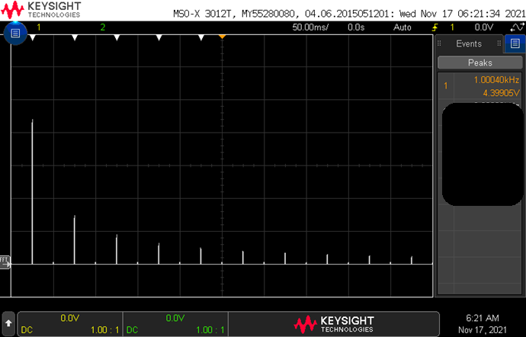

Figure 3.



Figure : The FFT of a 1kHz square wave with information about the magnitude of the peaks.

According to the data presented by the oscilloscope in



Figure 3, the 1kHz component of the 10V square wave has an amplitude of 4.4V RMS. Look at the data from your oscilloscope and put the corresponding magnitude of your 1kHz sinusoidal component in the Mag row of Table 1 under the 1kHz column. Continue to fill in the remaining magnitudes at higher frequencies.

In order to compare the values that you just filled in with the theoretical value from Equation 1, you need to scale all the measured amplitudes down so that the 1kHz amplitude is 1V. Do this by dividing each entry in the Measured row by the 1kHz measured voltage. This will normalize the measured voltages to a 1V to 0V scale, the same as the voltages in the theory row.

Frequency response of Audio amplifier front end

This past week you increased the capacitance of the by-pass capacitor for the front end of your Audio amplifier. Doing this reduced the corner frequency of the unintended high-pass filter. Let’s create a Bode plot to check how much the corner frequency has been reduced. You will use the same procedure as last week:

* Run a red and black banana cable from the power supply to the Audio board,
* Set the power supply to output 9V and 0.1A to the Audio board,
* Turn on the function generator and oscilloscope,
* Attach 2 oscilloscope probes to Ch1, Ch2 and function generator cable to Ch 1,
* Make sure that the function generator output is disabled by pressing the **[OUTPUT]** key for CH1 (the output light should be off),
* Attach the black ground clip of the function generator cable to a ground loop on the Audio board,
* Attach the black ground clip of the oscilloscope probe to a ground loop on the Audio board,
* Configure your oscilloscope as follows:

|  |  |
| --- | --- |
| Horizontal (scale) | 1ms |
| Ch1 probe | INPUT AMP_IN (male end of jumper wire) |
| Ch1 (scale) | 2V/div |
| Ch1 (coupling) | DC |
| Ch2 probe | CE_BIAS header (remove probe tip) |
| Ch2 (scale) | 2V/div |
| Ch2 (coupling) | DC |
| Trigger source | 1 |
| Trigger slope | ↑ |
| Trigger level | 2.5V |

* Configure your oscilloscope to measure to the phase shift and attenuation of the front-end,
  + [Meas] → Type → Phase
  + [Meas] → Setting → Source1: 2
  + [Meas] → Setting → Source2: 1
  + [Meas] → Add Measurement
  + [Meas] → Type → Ratio - Full Screen (make sure that the measurement is in dB)
  + [Meas] → Add Measurement
  + [↑ Back]
* Attach the red signal clip of the function generator to the AMP_IN input of the Audio board,
* Verify that everything is setup correctly by comparing your setup to Figure 4,

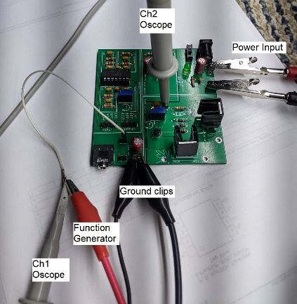

Figure : The setup to measure the frequency response of the common emitter input stage of the audio amplifier.

* Enable the function generator output,
* Observe the oscilloscope, it should look something like Figure 5,

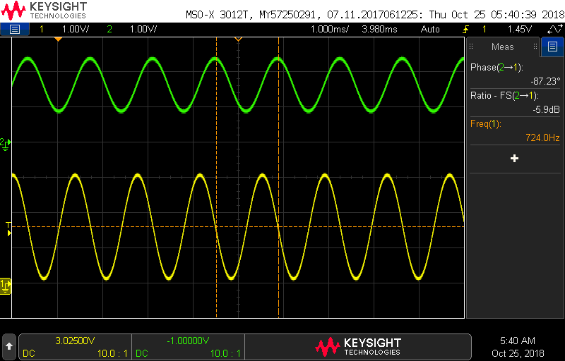

Figure : The input and output of the low-pass filter.

Now you are ready to collect the data to draw your Bode plot for the accidental BJT input high-pass filter. Download and open the audioBoardBehavior from Canvas and select the HPFexp tab. Copy all the information from last week’s lab into the blue columns under the “For 10nF” header.

To collect the data for the green columns under the “Modified” column, set the function generator to each frequency listed in column B and record the attenuation measured by the oscilloscope into the column E. As you add these data values, the Bode plots will automatically graph this data.

Before jumping in and measuring all the values, please take a few moments to read over the following list of points; it will save you from having to repeat measurements.

* If a cell in the Freq column does not have an entry, find the frequency (by adjusting the function generator) that generates the gain or phase listed in that row.
* As you decrease the input frequency, it may become very difficult to measure the magnitude and phase of the output waveform. When this happens, make the following modification to the oscilloscope:
  + Switch channel 2 into AC coupling, by pressing the channel 2 button and select Coupling: AC. Move the channel 2 ground reference to the middle of the upper half of the display,
  + Use the acquire function to average together several channel 2 waveforms. **[Acquire]** → AcqMode → Averaging → #Avgs: 8. You will notice that the waveform updates occur much more slowly and morph whenever you change the frequency. However, you will be able to measure incredibly small amplitudes (down to about -60dB) in this mode,

Include the Gain plot as an answer for the Turn-In.

Generating a Bode plot using the oscilloscope

You can use the function generator and oscilloscope together to generate a reasonable good facsimile of a Bode plot. To do this we are going to use a new features of the function generator, the trigger output. Let’s explore this new feature first, before generating a Bode plot on the oscilloscope.

* Turn on the function generator and oscilloscope,
* Connect one end of a BNC/BNC to the CH1/Synch/Ext Mod/Trig/FSK connector on the rear of the function generator.
* Connect the other end of the BNC/BNC cable to the Ch2 input of the oscilloscope.
* Grab a second BNC/BNC cable. Attach one end to oscilloscope Ch1 and the other end to CH1 of the function generator,

Configure your function generator as follows:

* Waveform: Sine
* Frequency: 1.0kHz
* Amplitude: 10.0V
* Offset: 0V

|  |  |
| --- | --- |
| Horizontal (scale) | 200us |
| Ch1 probe | BNC/BNC to CH1 of function generator |
| Ch1 (scale) | 5V/div |
| Ch1 (coupling) | DC |
| Ch2 probe | BNC/BNC to TRIG of function generator |
| Ch2 (scale) | 2V/div |
| Ch2 (coupling) | DC |
| Trigger source | 2 |
| Trigger slope | ↑ |
| Trigger level | 1.5V |

The trigger output of the function generator generates a positive edge when a “significant event” occurs on the function generator output. Significant even is quoted because it definition depends on how you have configured the function generator.

When the function generator is generating a sine wave, the trigger output goes high when the sine wave increases across its midpoint voltage. The trigger output goes low when the sine wave decreases across its midpoint voltage.

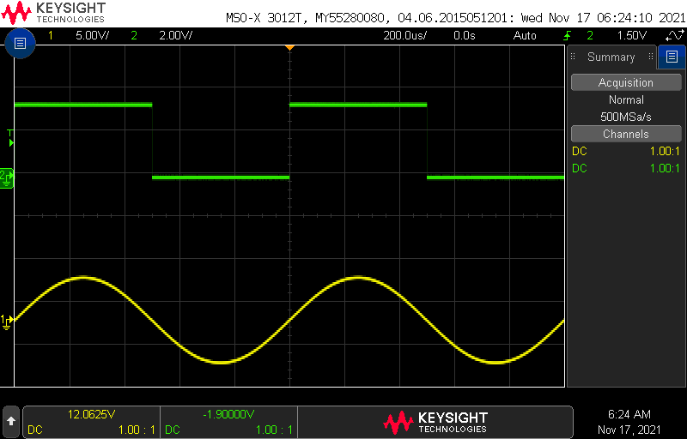

Now change the function generator configuration:

* [Sine] Freq 1.0kHz
* [Sine] Ampl 10.0V
* [Sine] Offset 0V
* [Sweep] Type Log
* [Sweep] Sweep Time 0.1sec
* [Sweep] Start 10Hz
* [Sweep] Stop 1000Hz

Keep the oscilloscope the same except for changing the horizontal scale to 20ms. You should now see that the TRIG output of the function generator corresponds to the start of the frequency sweep. The negative edge of the TRIG is largely unimportant but appears to happen about ½ way through the sweep.

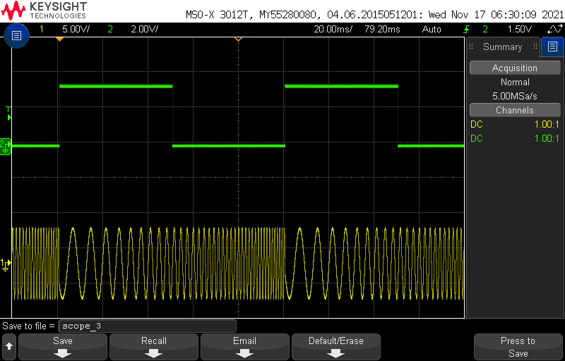

Now you are ready to generate the pseudo-Bode plot on the oscilloscope.

* Run a red and black banana cable from the power supply to the Audio board,
* Set the power supply to output 9V and 0.1A to the Audio board,
* Remove the BNC between the function generator CH1 and the oscilloscope Ch 1
* Attach an oscilloscope probe to Ch1 and function generator cable to Ch 1,
* Make sure that the function generator output is disabled by pressing the **[OUTPUT]** key for CH1 (the output light should be off),
* Attach the black ground clip of the function generator cable to a ground loop on the Audio board,
* Attach the black ground clip of the oscilloscope probe to a ground loop on the Audio board,
* Attach the red function generator clip to the AMP_IN input of the Audio board,
* Attach the oscilloscope probe to the CE_BIAS header (remove the scope tip).

Your setup should look like Figure 4. Now change the function generator configuration as follows:

* [Sweep] Sweep Time 2sec
* [Sweep] Start 10Hz
* [Sweep] Stop 47kHz

Change the oscilloscope configuration as follows:

* Horizontal scale 200ms
* Vertical scale Ch1 200nV

The function generator is sending the front-end of the Audio amplifier a continuous spectrum of sin wave from 10Hz to 47kHz. The oscilloscope is being trigger at the start of this sweep to display the amplitude of the BJT base.

Fiddle with the oscilloscope settings to get a reasonably good looking pseudo-Bode plot. Include the screen capture as your answer to the question in the Turn-In.

To save the image on the screen

* + [Save/Recall] → Save → Format → 24-bit Bitmap image (*.bmp)
  + [Save/Recall] → Save → Press to Save

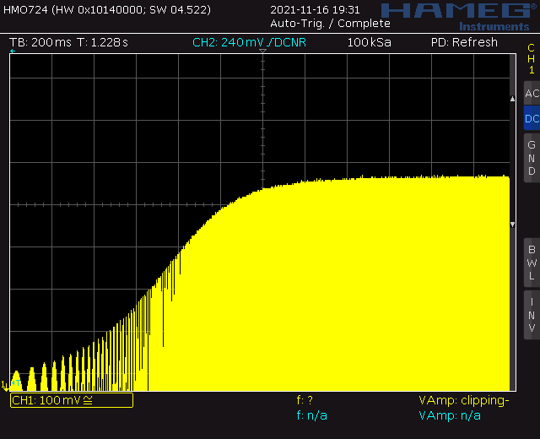

# Turn in:

Make a record of your response to numbered items below and turn them in a single copy as your team’s solution on Canvas using the instructions posted there. Include the names of both team members at the top of your solutions. Use complete English sentences to introduce what each of the following listed items (below) is and how it was derived.

# Fast Fourier Transform/ Fourier Series

* Table 1

Frequency response of Audio amplifier front end

* audioBoardBehavior Magnitude plot for old and new front-end

Generating a Bode plot using the oscilloscope

* pseudo-Bode plot screen shot from oscilloscope